Monday: Making the Most of Moringa School

Getting Started
Welcome to the Moringa School family, where we assist you on your journey to becoming a programmer in a few short months. Please make sure to read through both this entire document and the Student Handbook before the first day of coursework so that we all start on the same page.
(Links to an external site.)
Links to an external site.
Before we get started, we want to share our general philosophy at Moringa School. Any experienced developer will tell you that the more you learn about programming, the more you realize just how little you know. Moringa School is structured based off the understanding that being a developer is not about learning a fixed set of skills that you can apply for the rest of your career. From our personal experiences as software engineers and many conversations with hiring partners of all types, we believe that the languages, tools, and approaches you'll learn here are (still very important, but) much less important than the general skills of solving problems. Successful programmers embrace the limitations of what they can know, and get good at facing ambiguity and figuring out what they don't know. They develop a mindset in which not knowing the answer isn't a source of anxiety, but rather an opportunity to learn and explore.
Now, let's explore what you will learn. Each course here lines up with the different courses Moringa School offers. Our "Moringa Prep" course is designed to take you from limited experience to creating basic web pages, styling those pages so that they look nice, and adding interactivity. We also build your foundational problem solving skills, and learn about the tools that are essential to the programming trade.
As a student, once you have successfully completed Moringa Prep or tested straight into Moringa Core, you will be ready to dive into a one of our tracks. Regardless of which track you decide to take, Moringa School students are required to learn JavaScript. JavaScript is the only programming language web browsers understand (HTML and CSS are markup and styling languages, respectively, not programming languages), and with the importance of the web in modern application development, every programmer needs to know JavaScript. If you're more interested in front-end work, JavaScript will let you build out interactivity in your web pages, and if you're more interested in back-end work, JavaScript will let you wire up user interfaces to work with your backends and is even used to write backend code in some cases.
Finally, you'll pick a framework to learn. Android is used in mobile application development; Django is generally used for large-scale web applications. Don't get too hung up on picking the "right" language and framework, though. Odds are, at your first job, you might need to learn an entirely new set of skills and practices, and maybe even a new programming language. That's part of why we require all students to study at least two languages - with two under your belt, it's not too difficult to pick up a third.
No matter what languages and framework you learn, our best advice is not to think of Moringa School as a place to learn a specific language like Python or Java, or a framework like Django. Instead, think of Moringa School as a place to learn how to learn.
Okay, let's get going!

Making the Most of Moringa School
You've done it, you're in Moringa School! You've committed time, energy and dedication toward learning how to code. We can’t wait to see what you create, and want to do everything we can to support your success. As you're beginning to understand, we feel the biggest part of that success lies in your mindset and how you approach the challenging months that lie ahead.
Some things to remember are that this program is a marathon, not a sprint, and probably very different than any previous educational experiences you may have had. Differently from how your experience in high school, college, or your workplaces may have been - there are no shortcuts in our program. We need to have your full commitment in order to help make your own journey a success. It’s up to you to make the most of your experience!
Read the article 8 Easy Ways to Screw Up your Code School Experience, which provides a lot of insight into life at a code school and how to make the most of it.
(Links to an external site.)
Links to an external site.
Read the article Developing as a Developer to understand what the process of going to beginner to expert looks and feels like.
(Links to an external site.)
Links to an external site.
Read the article Why Learning to Code is so Damn Hard for a bit of mental preparation about the awesome and challenging experience you’re about to begin.
(Links to an external site.)
Links to an external site.
If this is your first week, use this information to prepare yourself with the best possible mindset before you walk in the door. If this is your 5th, 10th, or even 15th week, revisit this article to re-assess and recalibrate your perspective and approach in your remaining time here. It's never too late to make improvements!
Also, as a developer it is important to be up to date with what is happening in the tech industry. Read Hacker News often to see what is happening in the industry, and I recommend signing up for a daily digest so that you can receive the top articles in your email inbox daily.
(Links to an external site.)
Links to an external site.
(Links to an external site.)
Links to an external site.

Tuesday: Git, HTML, and CSS Objectives
This week we will be learning the building blocks of making basic web pages: HTML and CSS. We will also focus on using the command line and Git to create a daily workflow for our coding projects.

Daily Goals
Everyone learns at a different pace. Understanding is the most important goal every day. If you feel like you will not be able to complete all of the lessons on a given day, talk to a TM about ways to ensure that you are covering the day's objectives. Always focus on understanding the concepts at hand, not finishing the work as quickly as possible.

Plan
We will begin this week by practicing the command line, Git, Github, and exploring basic HTML. We'll create READMEs to include extra information with our projects on Github. We'll also learn a formatting language called Markdown to format READMEs. Then, we'll explore basic CSS to add styling to our web pages, and actually publish our sites online! Later in the week we will dive deeper into CSS by using divs and spans, floats, cascading, classes, ids, and the box model. Finally, we'll explore a tool called Bootstrap that offers even more powerful styling capability. You're in for a great time!
At the end of this section, you will be able to:
- Navigate the command line to access and create directories and files
- Use Git and GitHub to track the creation of static web pages
- Create a static webpage using HTML
- Style a static webpage using custom CSS rules in a linked stylesheet
- Create a project README.md in Markdown
- Adapt a webpage for responsive design

Independent Project Objectives
At the end of this section, you will complete an independent project. Your instructor will review this project for the following objectives:
- Use the most common HTML tags:
  - p, h, ul, ol, li, em, strong, a, img, div, span
- Create a custom-made stylesheet that uses cascading, the box model, and floats
- Implement standard indentation and spacing conventions of HTML and CSS
- Make Git commits regularly with clear messages that finish the phrase "It will…"
- Add a README to the GitHub repository that includes:
  - Author name
  - Project or program name
  - Description of program
  - Program setup instructions
  - Link to live version of site on GitHub Pages
  - Copyright and license information

uesday: Introduction and Interaction with the Command Line
One of the first tools every developer needs to get familiar with is the terminal. No matter which language you use, you will be using the terminal a lot. As a person new to programming, using the terminal interface of a computer may be something you'll do for the first time in this lesson.
When you open up your computer and want to access a file or program, it's likely that you do this using a graphical user interface, or GUI. This is simply the graphical, or visual, part of a computer program that the user can interact with.
For example, when you want to open up your internet browser and you click on the icon in your computer's menu bar, you are using the GUI of your computer's operating system to access the program. The cursor to indicate where on the screen you are clicking and the icons that represent programs are both parts of the graphical user interface.
Another example of a program with a GUI is a word processor. The GUI gives us a document to type in, a cursor to see where we're typing, letters on the screen to represent the text we've typed, menu options to format our text and save or documents, and more.
The GUI gives us a visual representation of what the computer program is doing underneath the hood. However, it's not the only way to interact with a computer. We can also use our computer's terminal interface, and you often will when developing. The terminal is a text-based interface that allows users to interact with the computer by typing commands into the command prompt.
You have probably navigated the folders and files on your computer using a GUI such as Finder on Mac or Files on Linux. In the next lesson, we'll see how we can create, update, delete, and navigate folders and files using the terminal. We'll also learn some additional functionality not available by using a GUI.

Accessing the Terminal

Ubuntu Setup
The Terminal application on a PC with Ubuntu installed can be accessed by pressing ctrl + Alt + T. Alternatively, you can locate the Terminal application by searching Terminal once you click on the ubuntu icon on the upper left side of your screen.

Mac Setup
The Terminal application on a Mac is located in the Utilities folder, which is located inside the Applicationsfolder. Alternatively, you can locate the Terminal application by clicking on the magnifying glass icon at the upper right corner of the screen and typing Terminal.

Command Prompt
When you open up your computer's terminal, you should see a blank screen with a few lines of text in the corner, followed by a $. This is called the prompt. It usually provides some contextual information such as who you are, your location on the computer, and other useful info. For example, the prompt on your computer might look something like this:
guest@moringa-Lenovo-B50-80:~$
In this example,
- guest is the name of the user currently logged in
- moringa-Lenovo-B50-80 is the nickname of the computer we're using
- ~ indicates that we are located in the Home directory (we'll learn more about what this means later)
- $ is the end of the prompt
Take note here that not all command prompts look the same. Your computer will likely have a different nickname or username, and you may be located somewhere else in the filesystem. There's no need to worry if the prompt on your computer looks different from the example above - this is totally normal.
After the prompt is a blinking grey rectangle, called the cursor. This is where you will be typing commands.
Both in the curriculum and in resources online, you will often see commands preceded by a $. When typing the commands yourself, do not type the $ - this is simply a common convention used to indicate that what follows is a command to be run.
Now that we have covered the basics of the terminal and command line, let's start using it. In the next lesson, we will learn some common and very useful commands, what they do, and how to use them.

Interacting with the Command Line
Now that we know what the command line is, how to access it, and what to use it for, let's start interacting with it. In this lesson, we will explore some of the most frequently used terminal commands. You will use these commands all the time at Moringa School, so start getting comfortable with them now.
To type a command, simply open your terminal program and start typing. Anything you type will appear where the cursor is. Once you've typed the command, hit Enter (Linux or Windows) or Return (Mac) to run it. For the remainder of this lesson, Enter and Return will be used interchangeably.

See current location with $ pwd
The first command on our journey will be pwd, which prints your current location to the screen. It stands for "print working directory".
See what happens when we use this command:
guest@moringa-Lenovo-B50-80:~$ pwd
After we hit Return or Enter, we see a series of words separated by slashes (/), also known as a file path. Each of the words is a directory, which is another word for a folder. So, in the example, the terminal returned:
/home/nancy
This tells us that we are located inside of the nancy directory, which is inside of the home directory.
This default directory is also called the home directory, and it is a sort of "entry point" for a system, and contains all of a user's files, directories, and programs. Remember when we first opened up the terminal and saw that our location was represented by a ~? The ~ symbol refers to the home directory.

List out contents of folder with $ ls
Now that we know which folder we are in, let's see what's inside of the folder. The next command we will learn is ls, which lists all the content of a folder (ls stands for "list"). When I type it on my computer, I see a list of all files and directories in that folder.
This tells us that I have each of the following folders in my Users/Guest directory:
guest@moringa-Lenovo-B50-80:~$ ls
Documents Downloads Music Pictures Public Templates Videos
Remember, just like Finder or File Explorer, the terminal interface lets us navigate and interact with our computer. ls tells us which files and folders are inside of a directory, just like the icons in the Graphical User Interface.

Change folders with $ cd
When we're using Finder and we want to move to a different folder, we find the icon for the folder where we want to go and double-click on it. In Terminal, we use the command $ cd folder-name (replacing folder-name with the name of the folder to which you'd like to navigate). cd stands for "change directory". Be sure to always type a space after any command that has an additional argument, such as the name of a directory in this example.
For instance, in order to navigate to my Documents folder, I use the command
guest@moringa-Lenovo-B50-80:~$ cd Documents
After hitting Return, the prompt reads
guest@moringa-Lenovo-B50-80:~/Documents$
Notice how Documents now precedes the $, indicating that our location has changed.
Here are a few more options to help you navigate your computer:
- If you type cd and press the Return key - with no directory specified - you'll go back to your Home folder. (You can also type cd ~ to go there.)
- If you type cd .. (that's two periods), you'll go to the directory above the one you're currently in. So if you're in your Home folder, and type cd .. you'll go to your Users folder.

Create folders with $ mkdir
The command mkdir stands for "make directory". We create a folder with a command like $ mkdir name-of-directory, replacing name-of-directory with whatever we would like to name the folder. Make sure you are in your computer's Desktop directory and let's create a folder named moringa-prep:
guest@moringa-Lenovo-B50-80:~/Documents$ mkdir moringa-prep
Now, if we run ls on our current folder, we can see that it contains a new folder named moringa-prep:
guest@moringa-Lenovo-B50-80:~/Documents$ ls
moringa-prep

Create new files with $ touch
The touch command works a lot like mkdir, but instead of creating a new directory, it creates a new file. The structure looks like $ touch new-file-name. For example, let's move to the moringa-prep directory we just made:
guest@moringa-Lenovo-B50-80:~/Documents$ cd moringa-prep
And let's create a new file named my-first-file.html:
guest@moringa-Lenovo-B50-80:~/Documents/moringa-prep$ touch my-first-file.html
Now when we list the files in the moringa-prep directory, we see that it contains my-first-file.html:
guest@moringa-Lenovo-B50-80:~/Documents/moringa-prep$ ls
my-first-file.html

Copy items with $ cp
The command cp stands for "copy", and it is used to copy files and directories. The basic structure of this command is $ cp original-file new-file, where original-file is the name of the original file, and new-file is what you want to name the copy. Here's how we would use it to create a copy of my-first-file.html named another-file.html:
guest@moringa-Lenovo-B50-80:~/Documents/moringa-prep$ cp my-first-file.html another-file.html
Now when we list the contents of the directory, we can see that there are two files:
guest@moringa-Lenovo-B50-80:~/Documents/moringa-prep$ ls
another-file.html my-first-file.html
The new file is an independent copy of the original, meaning that any changes to one do not affect the other.
A word of caution in naming copies. If there is already a file with the name of the new file in a folder, the old file will be overwritten and its contents will be lost, so be careful to give your new documents and folders a unique name.

Move and rename items with $ mv
The $ mv command stands for "move". It can both move and rename files. To see how this works, let's list the contents of our current directory:
guest@moringa-Lenovo-B50-80:~/Documents/moringa-prep$ ls
another-file.html my-first-file.html
Now, let's say we want to call it my-second-file.html instead of another-file.html. We use the $ mv command to rename it like this:
guest@moringa-Lenovo-B50-80:~/Documents/moringa-prep$ mv another-file.html my-second-file.html
Like $ cp, the basic structure of the $ mv command requires two pieces of information: the name of the file we would like to rename or move; and the new name or location for the file or folder.
Now we can use $ ls to see that the file has been renamed:
guest@moringa-Lenovo-B50-80:~/Documents/moringa-prep$ ls
my-first-file.html my-second-file.html
Let's see how we can use $ mv to move a file. First, let's create a folder named brand-new-folder to hold the file:
guest@moringa-Lenovo-B50-80:~/Documents/moringa-prep$ mkdir brand-new-folder
Here is how we move my-second-file into brand-new-folder:
guest@moringa-Lenovo-B50-80:~/Documents/moringa-prep$ mv my-second-file.html brand-new-folder/my-second-file.html
Here, we provided the name of the file that we want to move, which is my-second-file.html in this case. Then, separated by a space, we provided the new name and location of the file: brand-new-folder/my-second-file.html. By changing the name of the file from my-second-file.html to brand-new-folder/my-second-file.html, we are actually moving the file into the brand-new-folder directory.
See for yourself! List the contents of the moringa-prep directory, and see that my-second-file is no longer there:
guest@moringa-Lenovo-B50-80:~/Documents/moringa-prep$ ls
brand-new-folder my-first-file.html
Then, navigate to the brand-new-folder directory:
guest@moringa-Lenovo-B50-80:~/Documents/moringa-prep$ cd brand-new-folder
List the contents of the folder:
guest@moringa-Lenovo-B50-80:~/Documents/moringa-prep/brand-new-folder$ ls
my-second-file.html
And we can see that we have successfully used the $ mv command to move my-second-file.html into brand-new-folder.

Delete files with $ rm
We can delete files using the $ rm command. Let's see how it works. Here is how we delete my-second-file.html:
guest@moringa-Lenovo-B50-80:~/Documents/moringa-prep/brand-new-folder$ rm my-second-file.html
The basic structure of this command is $ rm file-to-delete, with a space between $ rm and the name of the file you'd like to delete. We can see with $ ls that the file has been removed:
guest@moringa-Lenovo-B50-80:~/Documents/moringa-prep/brand-new-folder$ ls
Now that the folder is empty, let's delete it as well. Note that we can not delete a folder from inside of it, so first, navigate up one folder:
guest@moringa-Lenovo-B50-80:~/Documents/moringa-prep/brand-new-folder$ cd ..
Then we can delete the brand-new-folder directory like this:
guest@moringa-Lenovo-B50-80:~/Documents/moringa-prep$ rm -r brand-new-folder
Notice that this looks a little different from removing a file: we have an extra option in there, -r. As a safety measure, $ rm does not delete directories by default. In order to delete directories, we need to include the -r after the $ rm, which stands for "recursive".
If we would like to delete a folder that contains files, we use the -rf flag instead: $ rm -rf folder-name.

Clear the terminal screen with $ clear
Finally, our terminal screen is getting pretty crowded with all of these commands! Sometimes it's nice to start with a blank screen. To clear the screen from previous commands, we use the command $ clear.
After the $ clear command has been issued, all that remains on the display screen is the command prompt. This does not actually clear any data, it simply gives us a blank screen to work with.
There are a ton of commands for the terminal, but knowing the commands covered in this lesson will make you pretty effective at using the command line. Being able to use the command line is one way to make yourself a powerful and efficient developer, so get in the habit early!

Resource: Cheat Sheet - Command Line
Here's a quick reference of all of the commands listed in this lesson. Feel free to reference this as you learn the commands - they'll be second nature before you know it.
- $ pwd: Prints the path of the current directory to the screen
- $ ls: Lists out the contents of the current folder
- $ cd directory-name: Changes the current directory to the one specified
- $ cd or $ cd ~: Changes the current directory to the home directory
- $ cd ..: Changes the current directory up one level
- $ mkdir directory-name: Creates a new directory (folder) in the current directory with the name specified
- $ touch file-name.html: Creates a new, empty file in the current directory with the name specified
- $ cp original-file.html new-file.html: Creates a duplicate copy of the first file listed and gives it the name of the second file listed. Both files still exist.
- $ mv original-file-name.html new-file-name.html: Moves the contents of the first file into the second file. Effectively renames the file.
- $ mv sample-file.html new-location/sample-file.html: Moves the first file into the folder specified for the second file.
- $ rm file-name.html: Removes the file specified.
- $ rm -rf directory-name: Removes the folder specified and all of the files inside.
- $ clear: Clears the terminal screen.

Terminology
- file path: The location of a file or folder in the file system. For example: Users/MoringaSchool/Pictures/cute-kitten.jpg is the path for the image called cute-kitten.jpg.
- directory: Another name for a folder in a file system. For example, Users/MoringaSchool/Pictures/cute-kitten.jpg has 3 directories: Users, MoringaSchool, and Pictures.
- home directory: The highest-level directory on a computer - this is the default directory when you open the terminal.

Tuesday: Practice the Command Line
Goal: Start using the command line to interact with your computer. Learn some basic commands.

Warm Up
Discuss the following question with your partner:
- What is the difference between a GUI and the command line?
- What are some advantages you can think of for using the command line?
- Name two commands and what they do.

Code
Follow along with the lesson to start interacting with your computer through the command line. Then, once you have experience using the command line and using basic commands, complete the following exercise in the terminal.
- If you're not already there, navigate to the home directory.
- Print your location to the screen to make sure you're in the right spot.
- List the contents of the Home directory to the terminal.
- Navigate to the Desktop directory.
- Create a directory named test.
- Navigate to the test directory.
- Create a file named file1.html.
- Create two more files named file2.html and file3.html. (Here's a tip: you can create two files with a single command! Simply separate the two file names with a space: $ touch file2.html file3.html)
- Create a directory named first-directory.
- Move file1.html into first-directory.
- Copy file2.html and name the copy file4.html.
- Rename file3.html to third-file.html.
- Navigate into first-directory.
- Delete file1.html.
- Navigate up one directory so that you are back in test.
- Print your location to verify that you are back in test.
- Delete first-directory.
- List the contents to the page to make sure that first-directory was successfully deleted.
- Clear the terminal screen.
Still want more practice? Check out the adventure game at this link that uses the same terminal commands that we just learned to navigate through the levels.
(Links to an external site.)
Links to an external site.

Tuesday: Using Atom and Git
In this lesson, we are going to walk through creating our first webpage in the Atom text editor and tracking the process using Git. Make sure you have installed both of these on your computer before we begin (see the instructions in the Pre-Course Setup if you haven't already).
(Links to an external site.)
Links to an external site.

Overview of Atom
Let's take a quick tour of Atom. Open the program. When we open the editor, we arrive on an empty file with the name "untitled". If we add content to the file, we see the x at the top becomes a blue circle. This indicates that there is content that hasn't yet been saved. We'll save this file as my-first-webpage.html using the .html extension to indicate that this will be a document written in HTML. The blue circle returns to a grey x and we know that our file's content has been saved.
Atom offers developers the ability to customize the editor's settings and shortcuts. Press Cmd + , (Mac) or Ctrl + , (Ubuntu and Windows) to see the Settings view.
One setting that we want to make sure we have in place is the tab length. Writing good code means making a habit of using consistent indentation. The standard for indenting lines of code is 2 spaces. We have confirmed that this is set to 2. So, rather than hitting the space bar twice, we can use the tab key for indentation.
You won't need to worry too much about all of the customization possibilities now but as you start gaining coding experience, remember that you can return to the Settings view to make updates to keyboard shortcuts, themes, or packages that add other functionality to the editor.

Git Project Setup
We've already started using command line to navigate our computer. Let's switch gears a little and expand on what we're able to do using the command line and start using Git and GitHub. In this lesson, we will create a simple webpage and track the process using Git.

Tracking changes with Git
At Moringa School, every project that we create will have its own directory (a folder in your laptop) and its own repository (a folder on Github). Now we are going to walk through creating a new project and tracking those changes with Git.
The first thing we need to do is create the project directory on our own computers. We'll do this just like we have done previously - Git will come in shortly. Open up Terminal and navigate to the folder where you would like to create your projects.
I am going to create a new folder named moringa-school-projects inside of my computer's Documents directory to hold all of the projects that I will create in class.
$ cd Documents
$ mkdir moringa-school-projects
$ cd moringa-school-projects
Now we are located in our moringa-school-projects directory, and we can add a new directory for this project. I am going to call this one hello-world (and just a bit of computer programming history for you: it's traditional to write some form of hello world as the first program or example you write in a new language).
$ mkdir hello-world
$ cd hello-world
Now we are located inside of our new hello-world directory, and we can turn it into a Git repository. We do this by initializing Git inside of the directory (make sure that you do this inside of the hello-world directory! Remember, you can always see your location with $ pwd):
$ git init
Initialized empty Git repository in /Documents/moringa-school-projects/hello-world/.git/
As the confirmation message reads, the Git repository has been initialized inside of a directory named .git. But when we try to list the contents of hello-world) with $ ls, where is it?
Directories that being with . are hidden directories, which means that they do not show up with the $ ls command. To view hidden files, we need to use the -a option like this, which stands for "all":
$ ls -a
.git
There's our .git directory! Let's cd into it and see what's inside:
$ cd .git
$ ls
HEAD description info refs
config hooks objects
Now, we're never actually going to be touching any of these files. The .git directory is where all of the changes we make to our project will be tracked. Whenever we add, edit, or delete files, Git will be keeping track of those changes in here. This is actually why the .git directory is hidden in the first place - to prevent us from making any changes that could interfere with Git's job.
Let's navigate back up to our main project directory:
$ cd ..
Now that we've set up our Git repository, we need to tell Git who is working on the project. If you are working solo, you can skip this step - you've already set the global user name and email for all projects on your computer.
Now our project is set up with a Git repository initialized. Let's start adding files to track!
Create an empty file in the project directory named hello-world.html:
$ touch hello-world.html
Now open the project in Atom using the following command:
$ atom .
The $ atom command tells the computer to open anything that follows it in Atom. The . means current directory, so the entire directory should open up in Atom.
Let's add some text to hello-world.html:
hello-world.html
<h1>Hello, world!</h1>
Here's what this looks like in Atom:
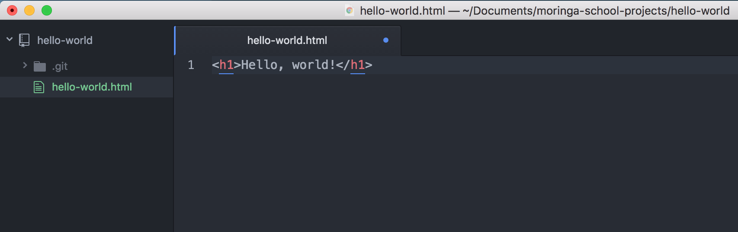
The little blue dot on the right of the page tab next to the file name (hello-world.html) means that the file has unsaved changes. Save the file with File > Save in the Atom menu bar.
We can see what Git is doing with our files with $ git status:
$ git status
On branch master

Initial commit

Untracked files:
(use "git add <file>..." to include in what will be committed)

hello-world.html

nothing added to commit but untracked files present (use "git add" to track)
This is Git telling us, "I noticed that you added a file named hello-world.html, but unless you use git add, I am not going to do anything with it."
Before we use $ git add, let's quickly go over a concept that can be a little confusing when first learning git: the staging environment and how it relates to a commit.
To reiterate, a commit is a record of what files you have changed since the last time you made a commit. A commit is like a save point, and we want to make a commit when we've made a notable change or addition to a project. Commits narrate the development of a project and allow you to go back to the state of a project at any point.
So, how do you tell Git which files to put into a commit? This is where the staging environment comes in. As we just saw, when you make changes to a repo, Git notices that a file has changed but won't do anything with it.
To add a file to a commit, we first need to add it to the staging environment. To do this, we can use the $ git add <filename> command. Here is how we add hello-world.html:
$ git add hello-world.html
Now when we run $ git status, we see that Git is tracking hello-world.html:
$ git status
On branch master

Initial commit

Changes to be committed:
(use "git rm --cached <file>..." to unstage)

new file: hello-world.html
Once you've used the git add command to add all the files you want to the staging environment, you can then tell Git to package them into a commit using the git commit command. Let's do that now.
$ git commit -m "Add initial hello world page"
To make a commit, we use the git commit command followed by the -m option (for "message"), followed by a short message describing the commit.
For consistency, commit messages should be in present tense and describe the change(s) made. As a rule of thumb, they should complete the phrase, "This commit will...". So when we look back at our commit history, we know that this commit will "add initial hello world page".
We can look at our Git commit history with the git log command:
$ git log commit de955b7ef50670e42d21f2366ea09cf517379475 Author: Albert Einstein <einstein@email.com> Date: Tue May 23 16:50:58 2017 +0300 Add initial hello world page
This command lists the commits made in a repository in reverse chronological order, so the most recent commits show up first. As we can see, this commit has been assigned a unique collection of numbers and letters, de955b7ef50670e42d21f2366ea09cf517379475. From now on, whenever we would like to return to this project exactly as it is right now, we will be able to return to this commit.
All right, let's add a short paragraph to our page to introduce ourselves:
hello-world.html
<h1>Hello, world!</h1>
<p>Welcome to my first website! I am about to embark on the exciting journey of learning how to code. Won't you join me?</p>
Let's check out our git status and see what it tells us:
$ git status
On branch master
Changes not staged for commit:
(use "git add <file>..." to update what will be committed)
(use "git checkout -- <file>..." to discard changes in working directory)

modified: hello-world.html

no changes added to commit (use "git add" and/or "git commit -a")
Git knows that hello-world.html has been modified, but the changes still need to be added to the staging environment and then committed. Let's do that now, using another option for git add:
$ git add .
$ git commit -m "Add intro paragraph"
[master 6ad09ba] Add intro paragraph
1 file changed, 1 insertion(+)
This time, we used $ git add . instead of $ git add hello-world.html. The . stands for the current directory (just like in the case of the command $ atom .), and $ git add . will add any changes in the directory that have not yet been added to the staging environment, so we can add multiple files at the same time.
Let's look at our project history now:
$ git log
commit 6ad09ba06206efdf5be66c56b0e425ed56ac70d1
Author: Albert Einstein <einstein@email.com>
Date: Tue May 23 17:26:22 2017 +0300 Add intro paragraph commit de955b7ef50670e42d21f2366ea09cf517379475 Author: Grace Hopper and James Bond <grace+james@> Date: Tue May 23 16:50:58 2017 +0300 Add initial hello world page
Notice that the most recent commit is at the top. We can make this a little easier to read by adding the --oneline option like this:
$ git log --oneline
6ad09ba Add intro paragraph
de955b7 Add initial hello world page
The seven-character string before each message is also a unique identifier for the commit and can be used in the same way (we will see how in an upcoming lesson).
This may seem like a lot of work for such minor changes on a single web page, but as we start building more projects - and more complex projects - we will see just how useful it is to track changes to our code this way.

Remote repositories on GitHub
So far, our code only exists on the machines where they were written. We have been tracking our changes in a local Git repository, which is the .git directory we've seen. However, it would be good to have a copy of our work backed up online, especially when our projects grow in size and have real-world implications. More importantly, we will need some way of collaborating with others on our work. When we want to push our work to the world, we will push it to a remote repository on GitHub. In this lesson, we will explore GitHub and how to use it.
What do we mean when we say local and remote? When we work on a repository that we can only access from the computer on which it is saved, we call this a local repository. All the code we have written so far has been written locally. If we want to work on the project from another device, we won't be able to access it. A remote repository, on the other hand, is a repository that is saved in a location outside of the computer where it was created, but still accessible by that computer (and other computers as well). At Moringa School, we will generally be saving our work to remote repositories.
Let's start by pushing our local repository to a remote repository on GitHub.
The first thing we need to do is create the remote repository on GitHub. Each partner needs to create a repository on their own GitHub account. Both remote repositories will link to the same local repository, but this will give each of you a personal record of the project.
Once you're logged in, click the New Repository button, which will take you to the Create New Repository page.
(Links to an external site.)
Links to an external site.
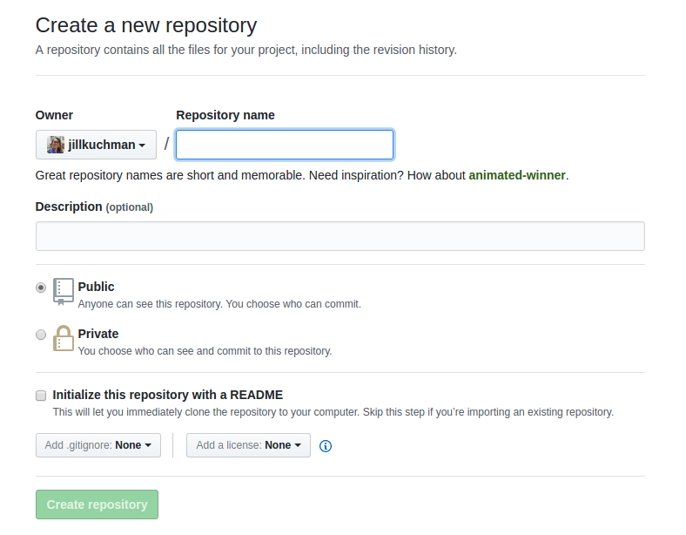
Let's go over the options on this page.
The text box under Repository Name is where we enter the name of the repository. You can name it anything you'd like, but give it a name that helps you identify the repository. It makes sense to give it the same name as the project folder for your local repository. For this project, let's use "hello-world".
Underneath the repository name, you can enter a description. The description is optional, but it can be helpful for others and your future self to have a quick reference for the description of the repository content.
You have the option to make a repository public or private. Because we're using free GitHub accounts, we can only select the Public option. As the page notes, anyone can see a public repository, but you can choose who has permission to contribute to it.
The last option asks whether you would like to initialize the project with a README. A README file contains information about the contents of the repository - stuff like the authors, description, setup instructions, and licensing information. Do not select this box. We will explore README files in an upcoming lesson.
With the repository name and description set, click the Create Repository button. You will be taken to a page that looks like this:
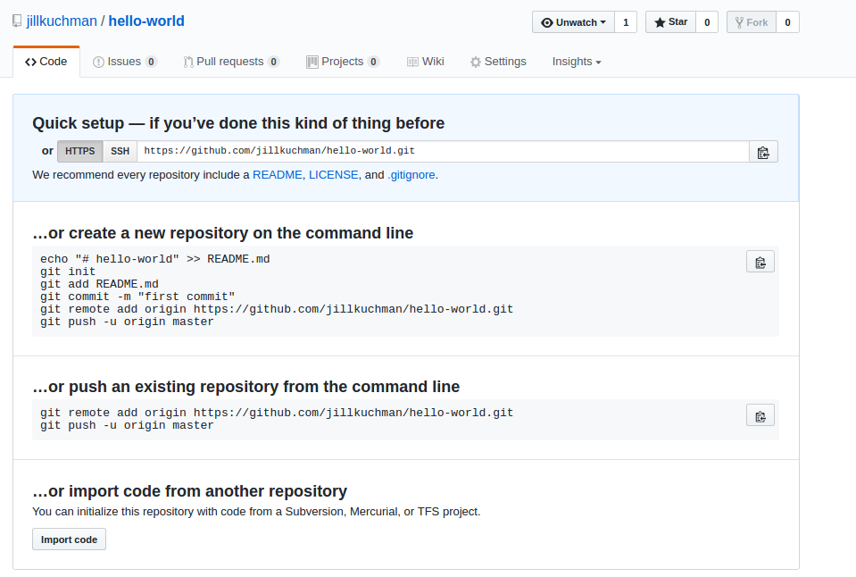
With this empty repository in place, we can push our locally-stored code to the new remote location.
First, we need to tell our local repository that a remote repository even exists somewhere online. We do this by adding it to Git's record. Just like Git wouldn't do anything with our files until we used git add, it won't acknowledge our remote repository yet, either.
To tell the repository about the remote location, we use the git remote add command like this:
$ git remote add origin https://github.com/moringaschool/hello-world.git
The git remote add command takes two arguments:
- The remote name, for example origin
  - The remote name can be anything - it's a nickname for the remote repository at the URL provided. By convention, the default name for the remote repository is named "origin", so we gave it that name here. However, you can give the remote any name you want, as well as work with multiple remotes.
- The remote location or URL, for example https://github.com/moringaschool/hello-world.git
  - This is the URL found in the Quick setup box at the top of the empty repository page
Please note that your command should include your repository info. Our URL is https://github.com/moringaschool/hello-world.git in this example, but you want to replace this with your own URL.
Now Git knows that there is a remote repository, and it's where you want your local repository changes to go. To confirm that Git has done this successfully, run this command:
$ git remote -v
The response looks something like this:
origin https://github.com/moringaschool/hello-world.git (fetch)
origin https://github.com/moringaschool/hello-world.git (push)
The -v option will give you a list of all of the remote repositories that your local repository knows about. There's one repository and it’s listed twice, which means it is available to push information to and to fetch information from. If both you and your partner have added remote repositories, then both repositories should be listed.
We are finally ready to push our code from local to remote. In other words, we will be copying it from our machine to the location on GitHub. To do this, we will use the git push command:
$ git push origin master
The git push command takes two arguments.
- First, we provide the name of the remote repository location. In this example, we wanted to push to the remote repository we just created, so we can use the nickname origin that we created.
- Second, we provide the name of the version of the code (also known as a branch, which we will learn more about in an upcoming lesson) we are pushing. As we start building more complex projects, we will have multiple versions of code at various stages of development on a single, local device. At the moment, we only have one branch, the "master" branch. master is the name given to this branch by Git, and the master is always considered the master copy.
When you push to GitHub on a computer where the user has not been set globally, the terminal will prompt you to enter your GitHub login information. This is GitHub protecting your account - only the owner of a repository is allowed to push to it. Once you have entered your login information, the terminal will give you some feedback that it is pushing your code to the remote repository. Go ahead and refresh the repository's page on GitHub, and you can see the file structure of the project, and the same commits that we saw in the terminal.

Cloning from GitHub
All right, we've pushed code from our personal machine up to GitHub. But as we mentioned before, one of the big advantages to using a service like GitHub is how it lets us collaborate with others on the same code. This requires copying the code from the remote repository into a local repository, a process called cloning.
To practice this, first, we need to remove the local repository from our personal computers. If you are in the hello-world directory (check with pwd):
$ pwd
Documents/moringa-school-projects/hello-world
Move up one directory with $ cd .. and remove the folder:
$ cd ..
$ rm -rf hello-world
Now the folder is gone, and we can clone our remote repository back onto our computers. On the main GitHub page for the repository, find the button that says Clone or download. A dialog box opens containing the URL for the repository. This is the same URL as the one we used for the remote. Copy the URL (either select the text and copy it manually, or click on the clipboard button next to the URL), and we will clone the repository using the git clone command in the terminal:
$ git clone https://github.com/moringaschool/hello-world.git
The terminal will print some feedback that it has successfully cloned the repository. Go ahead and list the contents of the folder and see that we now have a hello-world directory:
$ ls
hello-world
If we navigate into hello-world and run git log, we can see that our previous commits are still part of this repository.
Take a look at the Git remotes for the repository:
$ git remote -v
origin https://github.com/moringaschool/hello-world.git (fetch)
origin https://github.com/moringaschool/hello-world.git (push)
We see that the remote repository is automatically linked, and by default, it has the name origin. If we make changes to our local repository and want to push those to GitHub, we will use the origin remote nickname, like this:
$ git push origin master
One more (important) thing about Git repositories. Make sure that you never create or clone a repository inside of an existing repository. This creates something called a submodule, which has an icon like the one here for wild-beasts on GitHub:
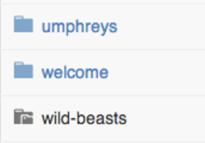
There are cases when you would want to do this, but for our purposes, it will only interfere with our Git process.
All right! We've just covered a lot of ground here! Don't worry about memorizing everything that we did here, and use the cheat sheet for reference when using Git in your daily workflow. It's okay if everything isn't making perfect sense right now - we will be using Git every day while at Moringa School, and like anything else, it will become more natural with practice.

Resource: Cheat Sheet - Git Commands

Daily Git Workflow

Set Name and Email

Solo Programming
Use the git config command to set your name and email for your local computer. This only needs to be done once.
$ git config --global user.name "Santa Claus"
$ git config --global user.email santa@northpole.com

Tracking Changes
- Create a new project directory with Git repository
In the terminal type these commands:
$ mkdir project-name
$ cd project-name
$ git init

- After adding files or making changes, track the changes.
Use this command to add all changes:
$ git add .

Use this command to add a specific file (replace filename.html with the name of the file to add):
$ git add filename.html

- Commit the changes.
In terminal:
$ git commit -m "add a short, descriptive present-tense message here describing the changes made"

- Create repository for project on GitHub at https://github.com/new.
(Links to an external site.)
Links to an external site.
- Add the remote to the project.
In terminal:
$ git remote add [remote name] [remote URL]

  - [remote name]: Name of the remote. When working solo, use origin.
  - [remote URL]: The URL of the remote on GitHub.
  - For example, this command adds a remote named origin to the repository at https://github.com/moringaschool/hello-world:
$ git remote add origin https://github.com/moringaschool/hello-world.git

- Push the changes to GitHub.
In terminal:
$ git push [remote name] [branch name]

  - [branch name]: Name of the branch you're working on.
  - For example, this command pushes to the remote named origin to the master branch:
$ git push origin master

- Clone repository from GitHub.
In terminal:
$ git clone [remote URL]

For example, this command clones the repository at https://github.com/moringaschool/hello-world:
$ git clone https://github.com/moringaschool/hello-world.git

Git Commands Overview
In this reference, examples in brackets [xxx], should be entirely replaced by what is indicated (do not leave the [ ] symbols).

Project Setup
- $ git init: Initializes new local Git repository in the current directory.

Tracking Files
- $ git add .: Adds ALL files with changes to be committed.
- $ git add [file]: Adds the named file to be committed.
- $ git commit -m "[message]": records all of the staged files permanently to the version history; message should describe the changes finishing the phrase "This commit will…".
  - Example: $ git commit -m "add submit functionality for the form"

Remote Repositories
- $ git remote add [remote name] [remote URL]: Adds a remote with the name specified for the repository to the remote URL provided.
- $ git remote -v: Shows the names and URLs for all of the remote repositories that the project's Git repository has stored.
- $ git push [remote name] [branch name]: Copies the code to the remote repository from the local Git repository.
- $ git clone [remote URL]: Copies the code and commit history from a remote repository to a local repository.

Reviewing Git Info
- $ git log: Lists commit history for the current branch.
- $ git log --oneline: Lists a condensed format of the commit history for the current branch.
- $ git status: Lists the files where changes have been made to be committed.

Tuesday: Forking with Git

Objectives
In this lesson, we will:
- Fork a project from an account to your account

Forking a Repository
A fork is a copy of a repository. Most commonly, forks are used to propose changes to someone's project or to use someone else's project as a starting point for your own idea. We are going to learn how to collaborate effectively later in the course. When going through Moringa Prep, you will be working in pairs for the most part. After working on your pair partner's computer and pushing changes to their GitHub account, there's the need to create a copy of the project in your own GitHub account.
To get started, open the GitHub repository we will be working with throughout this lesson. On the top right corner of your screen, you should see a button with the text 'Fork' as shown in the image below. Clicking on this button should start the process of copying the project/repository to your own account. This is the open source advantage of sharing projects on Github allowing people to collaborate on their work.
(Links to an external site.)
Links to an external site.
(Links to an external site.)
Links to an external site.

Click on that button which should result in a modal prompting you to choose the account to which you want to fork. Select your account name which should take you to the repo you forked in your account. For example, if your GitHub username is 'iantheninja' just like mine is, you should select it and not anything else that appears in the modal. This may take a couple of seconds so be patient as the process takes place. To know that the forking process is complete, check the top left corner of your repo. You should be in your account in a repo with the same name as the original repository (your_username/delani_studio_site). This shows that the forking process is complete.
It shows that you are now working on your forked version that was forked from iantheninja/delani_studio_site. Having copied iantheninja's repo to your own account, we can then proceed to clone it like we learned to do in the previous lesson. Remember that cloning makes a copy in a location on your device, in this case, your laptop.

Cloning a repo
Run the git clone command to clone the repo to your preferred location. At this point, you should have a moringa-school-projects folder which should host all projects you are going to work on at Moringa School. If you do not have such a folder, make sure you create one right now. Make sure to clone the repository to that directory (moringa-school-projects) to avoid making a mess of your folder structure. Take the next 5 minutes and figure out if you and your pair partner can figure out how to correctly clone the repo.
[5 minute practice session]
Confirm that you did the right thing by opening the moringa-school-projects folder and checking that you have the hello-world project. If you did not nail the task (cloning the repo), here's a bit of guidance to assist you. Follow the following steps:
- Open the terminal application.
- Navigate to the moringa-school-projects folder from the terminal. Remember to use the cd and mkdir commands where necessary.
- Run the command:
git clone https://github.com/your-username/hello-world.git
(Links to an external site.)
Links to an external site.
(remember to replace 'your-username' with your GitHub username to prevent cloning the wrong repository)
- Navigate to inside the cloned repository by using the change directory (cd) command.
- Open your editor by using the command atom . for Atom users or code . for Visual Studio Code users.
You are now ready to make modifications to the project you forked from the user 'iantheninja' (who seems to be a pretty cool person from his username). The project you forked now belongs to you. You should consult the licensing information in GitHub repos to make sure you do not get sued for using other people's work illegally. Play around with choosealicense.com to get to know what types of open source licenses there are.
(Links to an external site.)
Links to an external site.

uesday: HyperText Markup Language (HTML)
Many people think that creating a web page involves really complicated code that requires considerable studying to understand. This is not necessarily the case. In the next lesson we will make a simple web page together. But before we do that, let's quickly go over what the World Wide Web is.
The web is made up of mostly text files - like the ones you created to write your papers in high school - as well as some other files like images or videos. These files are stored on computers that are connected over networks. When you put a web site's address into your browser, you are really just requesting to see a particular file, or combination of files.
We've already seen a basic HTML file with our Hello World and Goodbye web pages. Now, we're going to focus on the basics of HyperText Markup Language, or HTML, that we previously just copy and pasted.
It looked a bit like this in Atom:
<h1>HTML Lesson</h1>
<h2>For Moringa School</h2>

<p>The goal for this lesson is to illustrate how simple HTML is to read and write by showing some text written in HTML and what it looks like when it is displayed in a web browser.</p>
When we open this file in our browser, it looks like this:

Tuesday: Indentation and Spacing
Before we start writing any HTML, it's important that we go over some rules to make sure that we're writing our code properly.
When writing HTML (or any other programming language), well-written code follows consistent indentation and spacing patterns. In some languages, indentation and spacing are required for the code to function properly. In HTML, inconsistent indentation and spacing will not impact the functionality of the web page but will cause your code to be difficult to read and understand.
Consider this example of HTML with poor indentation and spacing:
<!DOCTYPE html>
<html><head>
<title> Page Title</title>
</head>
<body><h1>Header</h1>
<p> Page content </p>
</body>
</html>

At first glance, it's difficult to see where elements begin and end, and what elements are nested within each other. Nested is another way of saying that the start tag and end tags of one element are inside of the start and end tags of another element.
Here's the same code with proper indentation and spacing:
<!DOCTYPE html>
<html>
<head>
<title>My first webpage!</title>
</head>
<body>
<h1>Hello world!</h1>
<p>Page content</p>
</body>
</html>
Much better!
In HTML, start tags and end tags on different lines are always left-aligned with one another. For example, when I see the <html> tag, I can scan vertically down to see its closing tag. It's clear that <head> and <body> are nested within <html>. The same goes for the <head> and <body> tag alignment.
When an element is nested inside another element, it needs to be indented two spaces from the opening tag. You can see in the above example that <head> is indented two spaces from <html>, and <title> is indented two spaces from <head>.
With a text editor like Atom, you can use the tab key to indent quickly. If you use the tab option, make sure tabs are set to two spaces. Some defaults are set to other amounts, such as four spaces, which is too much white space for HTML and is not standard practice.
To check your settings in Atom, go to the menu bar and select Atom > Preferences, then choose the Editor menu in the sidebar and scroll down to Tab Length.

Also, notice that there is no space between the text content of an element and its tags. For example, <h1>Header</h1> has no spaces between <h1> and the word Header.
Regardless of the language that you use to write code, learn its conventions for indentation and spacing. Getting in good habits now is much easier than breaking bad habits later. Practice consistency so that your code is easily understood by other developers, as well as yourself.

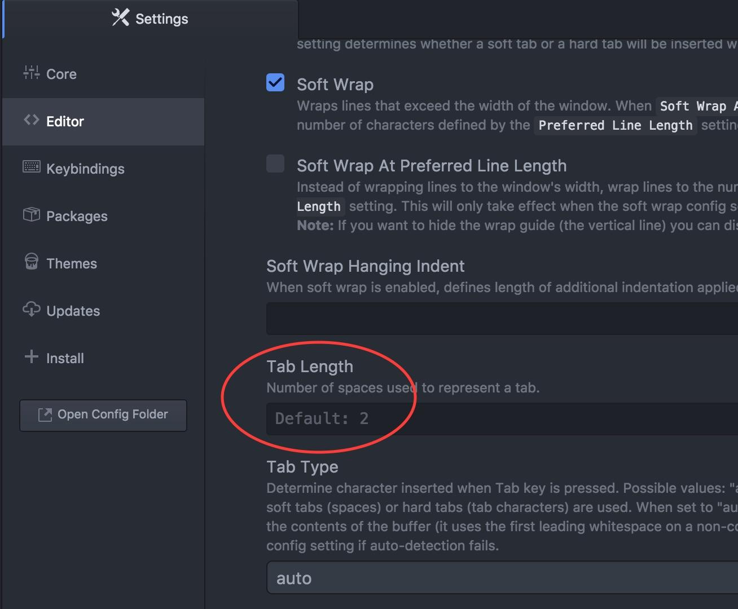

HyperText, or the "HT" of HTML, is just a fancy word for text that links to something else. The "ML" of HTML stands for markup language. As we can see in the example above, the text in the HTML file is normal text that is marked up with instructions written inside of these angle brackets <>, known as tags. The actual language of HTML is the instructions that we wrap around the text to format it and as we'll see, instructions for many other things like images, links, videos and more.

Tuesday: Practice with Indentation and Spacing - Cookie Recipe
Goal: Continue developing good indentation and spacing habits while simultaneously exploring the anatomy of a basic website, and practice cloning Git repositories. These skills will be used nonstop during your time at Moringa School.
Now it's time to practice using Git clone and honing your HTML skills by fixing some indentation and spacing. There is a cookie repository on GitHub that contains an HTML file with terrible indentation, spacing and HTML tag placement. It really needs your help.
(Links to an external site.)
Links to an external site.
- Use $ git clone to clone the repository onto your desktop. Be sure you have changed into your moringa-school-projects folder or the Documents directory before cloning the repository so that you do not accidentally clone the cookie repository inside of an existing project folder. Ask a peer if you're not sure if you are cloning the repository into the correct place.
- Create a new remote repository on your own GitHub for this project and link it to your local project folder by creating a remote (using the git remote add command).
- Go through the HTML file and fix every indentation error. Commit the changes. THEN...
- Go through the HTML file and fix every spacing error. Commit the changes. THEN ...
- Go through the HTML file and fix every tag placement error. Commit the changes.
- Have a TM come by and check your file for any errors that you have missed.
- Push your changes to the remote you created in your own GitHub account.
Today (and always!), focus on making sure that all of your code is properly indented and spaced and your HTML tags are properly placed around the content they contain.

uesday: Creating a Web Page
Now that we have an understanding of what HTML is, let's write some! In this lesson, we will create our first webpage. It will look like this:
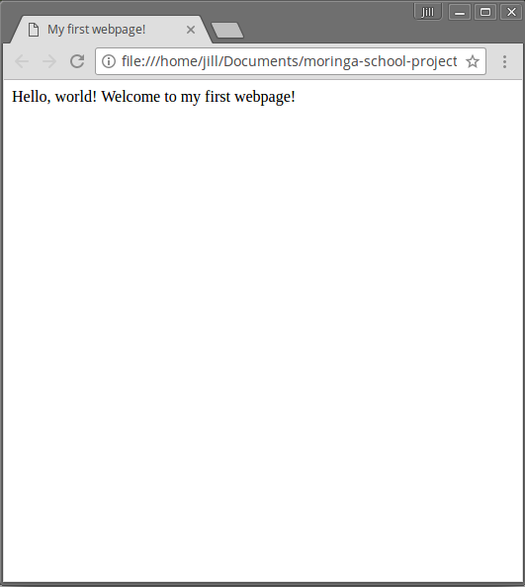
Let's create a project directory and initialize a Git repository for a new project called my-first-webpage.
As a review, here are the steps:
- Open Terminal.
- Make a project directory called my-first-website in your Desktop directory: $ mkdir my-first-website.
- Navigate into the project directory you just created: $ cd my-first-website.
- If you type $ pwd in Terminal now, you should see that you are in your project directory at /Users/Guest/Desktop/my-first-webpage.
- Within your project directory, initialize your Git repository: $ git init
- Create an empty file: $ touch my-first-webpage.html.
- Open the project directory in Atom: $ atom .
  - The command atom . opens the entire directory you are currently in because the . refers to current directory. If you only want to open the single file, you could instead type: $ atom my-first-webpage.html.
A note here about the name of the file. When you open a file on your computer, it knows what program to use to open the program by checking its extension. This is the group of letters that come after the name of the file, and indicates its file format. So, for example, example.mp3 will open in a program that plays music, because the ".mp3" extension indicates an audio file.
We gave our HTML document the file extension ".html", which tells our computer that it is an HTML file, and that it shouldopen the file in a web browser.
The name of the file can consist of any combination of letters, numbers or _ (underscore) and - (hyphen) characters. It is a good practice to start the file name with a letter and use lowercase letters to avoid capitalization errors.
Now, with my-first-webpage.html open in Atom, let's start by typing the following code (no more copying and pasting!):
my-first-webpage.html
<html>
</html>
These two tags are the standard start and end tags on any page. They need to be there. HTML elements can contain text and other HTML elements inside them, and these two tags will contain the rest of the HTML that makes up the page.
Now let's add the rest of the page structure. Modify the page so that it looks like this:
my-first-webpage.html
<!DOCTYPE html>
<html>
<head>
<title>My first webpage!</title>
</head>
<body>

</body>
</html>
We've created our first web page - let's commit it!
$ git add my-first-webpage.html
$ git commit -m "add initial page structure"
So, what's going on here?
The <!DOCTYPE html> tag at the top tells the browser that this document contains HTML, and specifically that it contains the newest version of HTML, HTML5. (An example of a doctype for an older version of HTML is <!DOCTYPE html PUBLIC "-//W3C//DTD XHTML 1.0 Strict//EN" "http://www.w3.org/TR/xhtml1/DTD/xhtml1-strict.dtd">) Without the the doctype declaration, your HTML code will likely still work, as HTML5 is the current standard. In the future, however, a new standard will override HTML5. Future browsers may assume you're using a different, newer standard, in which case your document will be interpreted incorrectly. To make sure your document is forever interpreted correctly, always include at the very beginning of your HTML documents.
HTML pages are made up of two distinct parts - the head part, and the body part. The head contains things that won't appear on your page. Many of the elements that go in the head are advanced stuff to tell search engines and browsers about the page, so the only one you need to know for now is <title>. We will see more in upcoming lessons.
The text inside the title element is the text that appears at the very top of your browser window when you view the page. We decided to call this page "My first webpage!", but you can type whatever you want.
The body section is the main part of your page. Everything between those two tags will be visible on your page. Let's type something there now.
my-first-webpage.html
<!DOCTYPE html>
<html>
<head>
<title>My first webpage!</title>
</head>
<body>
Hello, world!
Welcome to my first webpage!
</body>
</html>
That's it - we've written our first web page!
Now let's see what that looks like in a web browser, such as Google Chrome or Internet Explorer. You may have seen some of these before:

Remember in the last lesson how we said that when you put a web site's address into your browser, you are just requesting to see a particular file? As it turns out, we can use web browsers to display files on our computers as well.
Open the file location in your file explorer and double-click the icon for my-first-webpage.html. The page should open in a web browser and look like the image at the beginning of this lesson.
Okay, that's not very fancy - it's just some text in the corner of the screen. Over the next lessons, we will learn how to use HTML (and more) to format our pages.

